1.Inline Declaration:

Before 7.4 New syntaxes were not introduced the variable needs to be declared before using it, now using inline declaration variable can we declare and use at the same time, below are some of the syntax which has changed after 7.4.

**Whenever data is to be moved to a variable, can be declared at the same instance,**

*&---------------------------------------------------------------------*  
*& Report ZYNY_NEW_ABAP_00  
*&---------------------------------------------------------------------*  
*&  
*&---------------------------------------------------------------------*  
REPORT ZYNY_NEW_ABAP_00.  
  
*Old Syntax.  
DATA var1 TYPE char5.  
var1 = 'ABC'.  
WRITE : / VAR1.  
  
*New Syntax.  
DATA(var2) = 'ABC'.  
WRITE : / VAR2.

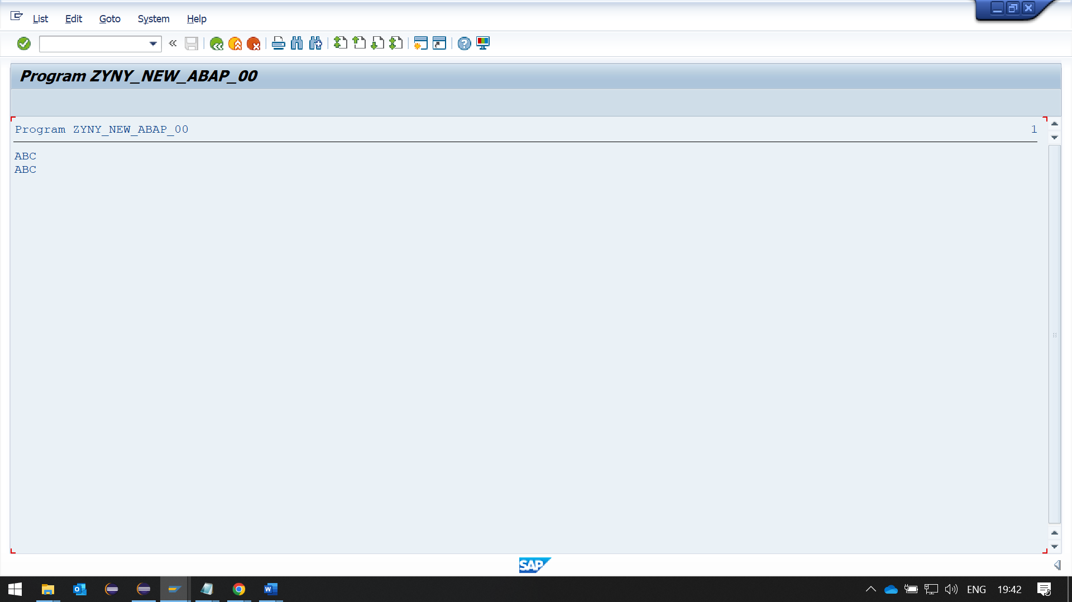

**\*Select Single From DataBase Table into Work Area**

*&---------------------------------------------------------------------*  
*& Report ZYNY_NEW_ABAP_01  
*&---------------------------------------------------------------------*  
*&  
*&---------------------------------------------------------------------*  
REPORT ZYNY_NEW_ABAP_01.  
  
*Old Syntax.  
DATA wa TYPE ....  
SELECT SINGLE fld1 fld2 FROM ....  
INTO wa   
WHERE fld1 = var1  
AND fld2 = var2.  
  
*New Syntax.  
SELECT SINGLE fld1, fld2, FROM ....  
INTO @DATA(wa)  
WHERE fld1 = @var1  
AND fld2 = @var2.

**\*Selecting Data From DataBase Table Into Internal Table,**

*&---------------------------------------------------------------------*  
*& Report ZYNY_NEW_ABAP_02  
*&---------------------------------------------------------------------*  
*&  
*&---------------------------------------------------------------------*  
REPORT ZYNY_NEW_ABAP_02.  
  
*Old Syntax.  
DATA itab TYPE TABLE OF ....  
SELECT fld1 fld2 FROM ....  
INTO TABLE itab  
WHERE fld1 = var1  
AND fld2 = var2.  
  
*New Syntax.  
SELECT fld1, fld2 FROM ....  
INTO TABLE @DATA(itab)  
WHERE fld1 = @var1  
AND fld2 = @var2.

**\*Declaration of the work area while operation on Internal Table,**

*&---------------------------------------------------------------------*  
*& Report ZYNY_NEW_ABAP_03  
*&---------------------------------------------------------------------*  
*&  
*&---------------------------------------------------------------------*  
REPORT ZYNY_NEW_ABAP_03.  
  
  
*Old Syntax.  
  
DATA wa TYPE MARA.  
DATA ITAB TYPE TABLE OF MARA.  
LOOP AT ITAB INTO wa.  
  
*or  
READ TABLE ITAB into wa WITH KEY field1 = var1.  
  
*New Syntax.  
LOOP AT ITAB2 INTO data(wa).  
  
*or  
READ TABLE ITAB2 into data(wa) WITH KEY field1 = var1.

**\*Moving Data From One Table To Other.**

*&---------------------------------------------------------------------*  
*& Report ZYNY_NEW_ABAP_03  
*&---------------------------------------------------------------------*  
*&  
*&---------------------------------------------------------------------*  
REPORT ZYNY_NEW_ABAP_03.  
  
  
*Old Syntax.  
DATA lt_tab LIKE itab.  
lt_tab[] = itab[].  
  
*New Syntax.  
DATA(lt_tab) = itab[].

**\*Assigning Field Symbols**

*&---------------------------------------------------------------------*  
*& Report ZYNY_NEW_ABAP_03  
*&---------------------------------------------------------------------*  
*&  
*&---------------------------------------------------------------------*  
REPORT ZYNY_NEW_ABAP_03.  
  
*Old Syntax.  
FIELD-SYMBOLS: <line> type …  
LOOP AT itab ASSIGNING <line>.  
  
*or   
READ TABLE itab ASSIGNING <line> WITH KEY FLD1 = VAR1.New Syntax.  
LOOP AT itab ASSIGNING FIELD-SYMBOL(<line>).  
  
*OR  
READ TABLE itab ASSIGNING FIELD-SYMBOL(<line>) WITH KEY FLD1 = VAR1.